Lagged cross-correlation: EURUSD and NZDUSD
Method 12 / daily log returns / K_max=10 / Alpari D1 full available history

Study setup
Logical pair: EURUSD , NZDUSD
Broker symbols: EURUSD_i , NZDUSD_i
Snapshot: 2026-11-03_majors_alpari_D1
Timeframe: D1
Matched return window: 1999-01-05 to 2026-11-02 (UTC bar dates)
Matched return count n: 7186
Dropped unfinished last bar dated 2026-11-03 UTC after a tick-volume check against the prior complete day.
Lag definition: rho_X->Y(k) = Corr(x_t, y_{t+k}) on matched D1 bars
K_max = 10; headline lag k = 1 (both directions)
Complete matched rows (Excel): EURUSD-NZDUSD_Lagged_D1.xlsx
Complete matched rows (HTML table): EURUSD-NZDUSD_Lagged_D1_data.html

Method carried forward
Lagged cross-correlation measures Pearson correlation between matched daily log returns of close, ln(close_t / close_t-1), after shifting one series forward by k bars on the matched panel. Quotes are not inverted. rho_{X->Y}(k) = Corr(x_t, y_{t+k}) with n_k = n - k. K_max = 10 is fixed before estimation. The headline is the pre-specified lag k = 1 in both directions. k = 0 is the same-bar side check. The lag inside 1..10 with the largest absolute rho is stored as a descriptive column only; it is not a selected result. This is a linear screen, not proof of forecast edge, economic cause, or a trading signal.

Results (headline k=1)
rho_EURUSD->NZDUSD(1): -0.001310 (n=7185)
95% Fisher interval EURUSD->NZDUSD: [-0.024432, 0.021814]
rho_NZDUSD->EURUSD(1): -0.023382 (n=7185)
95% Fisher interval NZDUSD->EURUSD: [-0.046480, -0.000259]
Same-bar rho(k=0): 0.549808
Largest |rho| among k=1..10 (descriptive only, not selected): EURUSD->NZDUSD k=2 rho=0.030539; NZDUSD->EURUSD k=1 rho=-0.023382

CCF table
k | rho_EURUSD_to_NZDUSD | n_EURUSD_to_NZDUSD | rho_NZDUSD_to_EURUSD | n_NZDUSD_to_EURUSD
0 | 0.54980813 | 7186 | 0.54980813 | 7186
1 | -0.00131001 | 7185 | -0.02338207 | 7185
2 | 0.03053858 | 7184 | -0.00633155 | 7184
3 | -0.02243345 | 7183 | -0.00663137 | 7183
4 | 0.02946332 | 7182 | 0.00082352 | 7182
5 | -0.00998352 | 7181 | 0.01175072 | 7181
6 | -3.294e-05 | 7180 | -0.02247743 | 7180
7 | 0.00675102 | 7179 | -0.00855538 | 7179
8 | 0.01702759 | 7178 | 0.00905743 | 7178
9 | 0.00860047 | 7177 | -0.02322093 | 7177
10 | -0.00240467 | 7176 | 0.01706811 | 7176

Conclusion
At the pre-specified lag k=1 for EURUSD and NZDUSD, rho_{EURUSD->NZDUSD}(1) = -0.0013 (n=7185) and rho_{NZDUSD->EURUSD}(1) = -0.0234 (n=7185). Same-bar rho(k=0) = 0.5498. Largest |rho| among k=1..10 is descriptive only: EURUSD->NZDUSD at k=2 (0.0305); NZDUSD->EURUSD at k=1 (-0.0234). This is a linear screen, not forecast proof or a trading signal.

Charts
Daily closes

Daily log returns

CCF both directions k=0..10
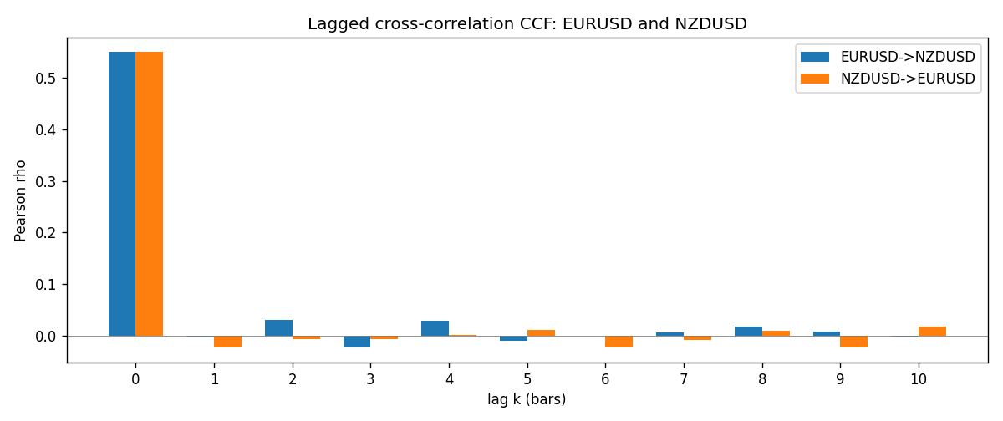

Data report
Every matched row is stored in the sibling Excel workbook named EURUSD-NZDUSD_Lagged_D1.xlsx (sheet matched_rows). The CCF sheet holds rho(k) for k=0..10. Embedding all rows as a Word table is impractical; the Word file holds column summaries and the first and last 15 rows.
Columns: time, EURUSD_open, NZDUSD_open, EURUSD_high, NZDUSD_high, EURUSD_low, NZDUSD_low, EURUSD_close, NZDUSD_close, EURUSD_tick_volume, NZDUSD_tick_volume, EURUSD_spread, NZDUSD_spread, EURUSD_real_volume, NZDUSD_real_volume, EURUSD_log_return, NZDUSD_log_return
Column summaries (matched calculation rows)
column | count | mean | std | min | 25% | 50% | 75% | max
EURUSD_open | 7186 | 1.181357 | 0.15085833 | 0.8272 | 1.086165 | 1.16609 | 1.2939475 | 1.5995
NZDUSD_open | 7186 | 0.65641776 | 0.10819833 | 0.3913 | 0.59134 | 0.6684 | 0.7249075 | 0.88218
EURUSD_high | 7186 | 1.1864878 | 0.15145386 | 0.8326 | 1.09024 | 1.17121 | 1.2993075 | 1.6038
NZDUSD_high | 7186 | 0.66033433 | 0.10869188 | 0.3961 | 0.59475 | 0.67202 | 0.72936 | 0.88421
EURUSD_low | 7186 | 1.1763494 | 0.15017707 | 0.8227 | 1.082045 | 1.162475 | 1.2884175 | 1.5865
NZDUSD_low | 7186 | 0.65273031 | 0.10779283 | 0.3897 | 0.5880725 | 0.664185 | 0.720965 | 0.87988
EURUSD_close | 7186 | 1.1813978 | 0.15082738 | 0.8267 | 1.0860425 | 1.16602 | 1.2939725 | 1.5997
NZDUSD_close | 7186 | 0.65649194 | 0.10819527 | 0.3907 | 0.59159 | 0.66842 | 0.725015 | 0.8822
EURUSD_tick_volume | 7186 | 103205.25 | 173535.32 | 218 | 9413.25 | 52774.5 | 99579.75 | 1471626
NZDUSD_tick_volume | 7186 | 68709.014 | 123134.25 | 16 | 5585.5 | 33893.5 | 58510.5 | 1127682
EURUSD_spread | 7186 | 19.350682 | 16.562781 | 0 | 8 | 12 | 27.5 | 50
NZDUSD_spread | 7186 | 30.284303 | 25.649992 | 0 | 9 | 17 | 47.5 | 80
EURUSD_real_volume | 7186 | 4.0330482e+10 | 1.6691688e+11 | 0 | 0 | 0 | 0 | 3.6149665e+12
NZDUSD_real_volume | 7186 | 1.6701379e+10 | 8.497804e+10 | 0 | 0 | 0 | 0 | 2.705649e+12
EURUSD_log_return | 7186 | -4.99e-06 | 0.00579654 | -0.03123819 | -0.00323792 | 0 | 0.00325328 | 0.03433183
NZDUSD_log_return | 7186 | 9.3e-06 | 0.0076423 | -0.07027433 | -0.00425367 | 0.00022883 | 0.00457975 | 0.05966839
First 15 matched rows (selected columns)
time | EURUSD_close | NZDUSD_close | EURUSD_log_return | NZDUSD_log_return
1999-01-05 | 1.1758 | 0.5372 | -0.0048360507 | -0.0018597736
1999-01-06 | 1.1623 | 0.5383 | -0.011547966 | 0.0020455609
1999-01-07 | 1.1712 | 0.5417 | 0.0076280636 | 0.0062963171
1999-01-08 | 1.1585 | 0.5414 | -0.010902799 | -0.00055396548
1999-01-11 | 1.1503 | 0.547 | -0.007103287 | 0.010290425
1999-01-12 | 1.1555 | 0.5441 | 0.0045103728 | -0.0053157489
1999-01-13 | 1.1681 | 0.5387 | 0.010845346 | -0.0099742238
1999-01-14 | 1.1681 | 0.5386 | 0 | -0.00018564931
1999-01-15 | 1.1563 | 0.5382 | -0.010153245 | -0.00074294208
1999-01-18 | 1.1605 | 0.5372 | 0.0036256946 | -0.0018597736
1999-01-19 | 1.1603 | 0.5382 | -0.00017235436 | 0.0018597736
1999-01-20 | 1.1566 | 0.5404 | -0.0031939256 | 0.0040793678
1999-01-21 | 1.1601 | 0.5426 | 0.0030215416 | 0.0040627941
1999-01-22 | 1.1587 | 0.5361 | -0.0012075213 | -0.012051689
1999-01-25 | 1.1552 | 0.5342 | -0.0030251979 | -0.0035504102
Last 15 matched rows (selected columns)
time | EURUSD_close | NZDUSD_close | EURUSD_log_return | NZDUSD_log_return
2026-10-13 | 1.11965 | 0.56127 | 0.0037402957 | 0.0047326165
2026-10-14 | 1.11545 | 0.55918 | -0.0037582255 | -0.0037306483
2026-10-15 | 1.12172 | 0.56185 | 0.0056053107 | 0.0047634855
2026-10-16 | 1.12371 | 0.56509 | 0.0017724895 | 0.0057501001
2026-10-19 | 1.12086 | 0.56616 | -0.0025394633 | 0.0018917133
2026-10-20 | 1.12354 | 0.56827 | 0.0023881672 | 0.0037199341
2026-10-21 | 1.12318 | 0.57003 | -0.00032046717 | 0.0030923331
2026-10-22 | 1.12139 | 0.56815 | -0.0015949606 | -0.0033035227
2026-10-23 | 1.11989 | 0.56991 | -0.001338521 | 0.0030929853
2026-10-26 | 1.11735 | 0.56826 | -0.0022706559 | -0.0028993932
2026-10-27 | 1.11272 | 0.56811 | -0.004152342 | -0.00026399852
2026-10-28 | 1.1152 | 0.56261 | 0.0022262927 | -0.0097283914
2026-10-29 | 1.11772 | 0.56296 | 0.0022571351 | 0.00062190714
2026-10-30 | 1.11644 | 0.56307 | -0.0011458446 | 0.00019537668
2026-11-02 | 1.11881 | 0.56161 | 0.002120569 | -0.0025962955

